Student Name | G. Manasa
Student Registration Number | 241U1R3007 | Class &Section: CSE(DS)
Study Level: UG/PG | UG | Year &Term: I & II
Subject Name | Digital Electronics

Name of the Assessment | Reflective Journal -8
Date of Submission | 31/08/2025

Reflective Journal Template
Journal Entry Guidelines | Description
1. Experience (Class Content) | Briefly describe the topics or concepts discussed during the class.
2. Feelings (Emotional Reactions) | Share your emotional reactions and thoughts during the class.  How did you feel while learning this theory?  Did the class evoke specific emotions or questions?
3. Learning (Key Insights) | Reflect on what you learned from the class.  Highlight the key insights or fundamental concepts you gained from the class.
4. Application (Practical Use) | Describe how you plan to apply the theory you've learned in real-life situations or in your academic/career endeavours.  Explain the practical utility of this theory.

Sample Journal Entry

Date | 31-08-2025
Journal Entry Topic | Sequential Circuits
1. Experience (Class Content) | When I started learning about sequential circuits, I realized that they were different from the simple combinational circuits that I had studied earlier. Combinational circuits only depend on the present input, but sequential circuits depend on both the present input and the past output. This was something new for me, and at first, I struggled to understand the difference. While going through the lesson, I learned that the main components of sequential circuits are logic gates and memory elements like flip-flops and latches.  In class, we discussed how sequential circuits can be synchronous or asynchronous, and how clock signals play an important role in controlling their operation. I remember trying to draw the diagrams of SR latches, JK flip-flops, and D flip-flops. At first, the truth tables and characteristic equations were confusing, but after repeated practice, I became more comfortable with them. I also did some problem-solving exercises to understand how the next state (Q(t+1)) is derived from the present state and the inputs.  As the topic progressed, I studied different types of flip-flops: SR, JK, D, and T flip-flops. Each one had its own truth table, characteristic equation, and special purpose. At first, I found it difficult to remember the difference between them, but after practicing many diagrams and equations, I started recognizing the patterns. For example, I learned that the JK flip-flop is an improvement of the SR flip-flop because it removes the invalid state problem. I also found the T flip-flop very interesting because it toggles between states and is mainly used in counters.  The master-slave flip-flop was another important concept I experienced. It taught me how circuits can be designed in such a way that the master stores the input first and then transfers it to the slave after one full clock pulse. This was a bit tricky at first, but when I related it to real-life situations, like how a teacher first prepares notes (master) and then passes them to students (slave), I understood the concept better.  This experience was both challenging and exciting. I realized that sequential circuits are not just about solving equations or memorizing truth tables but about understanding how information is stored and processed inside digital systems.
2.Feelings (Emotional Reactions) | At the beginning, I felt nervous because sequential circuits seemed difficult and filled with technical terms. But when I slowly related each concept with practical examples like traffic lights, washing machines, calculators, and computers, I felt more confident. I was excited to realize how the circuits I studied are behind so many devices in our everyday life. By the end, I felt satisfied and proud that I could explain such a complex topic in a simple way.
3. Learning (Key Insights) | 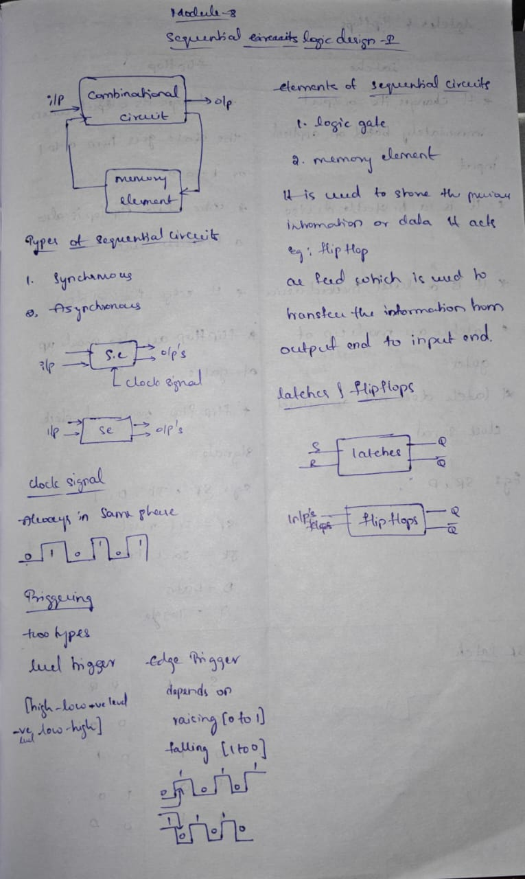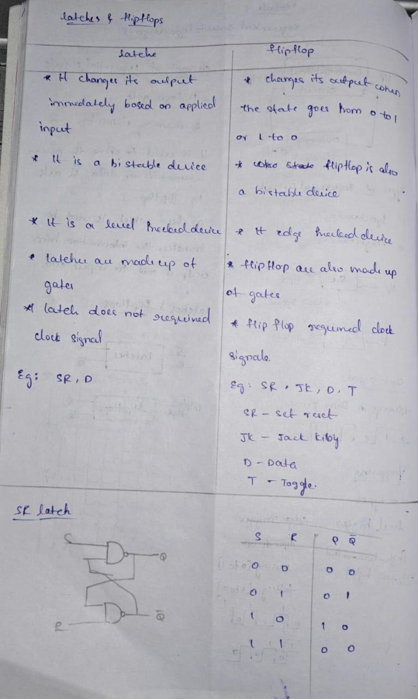  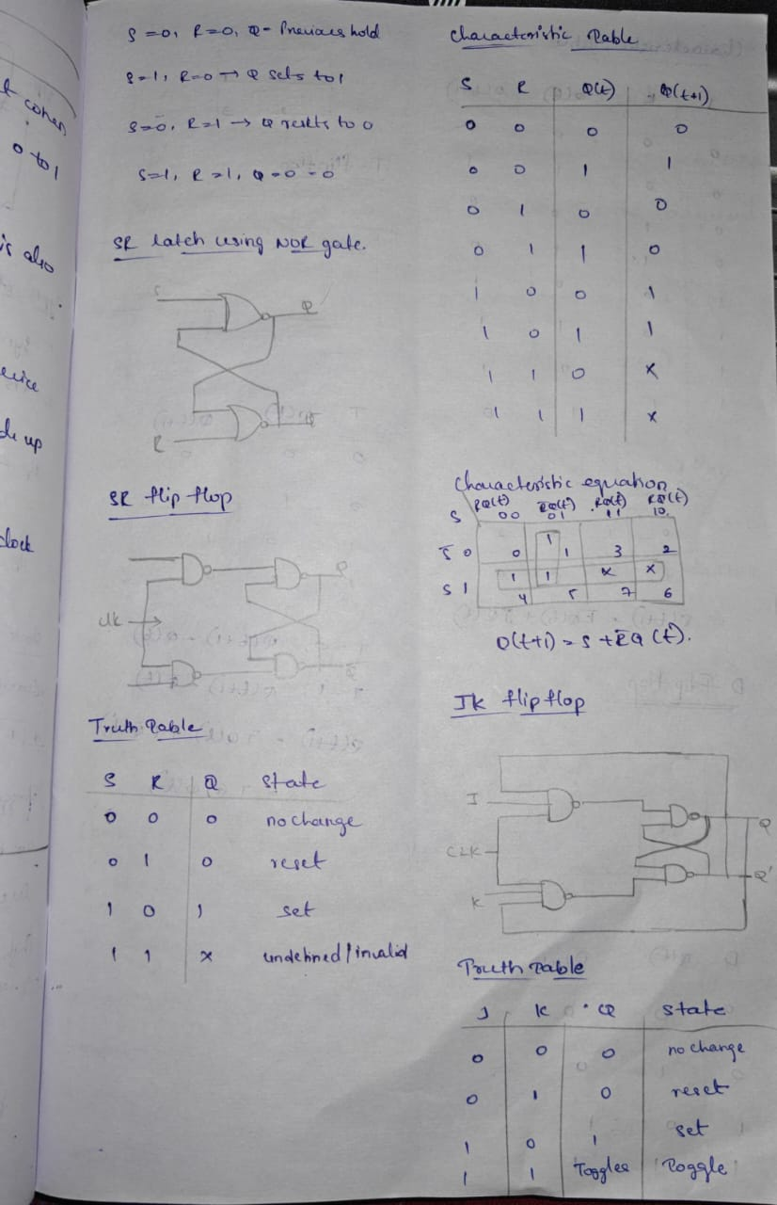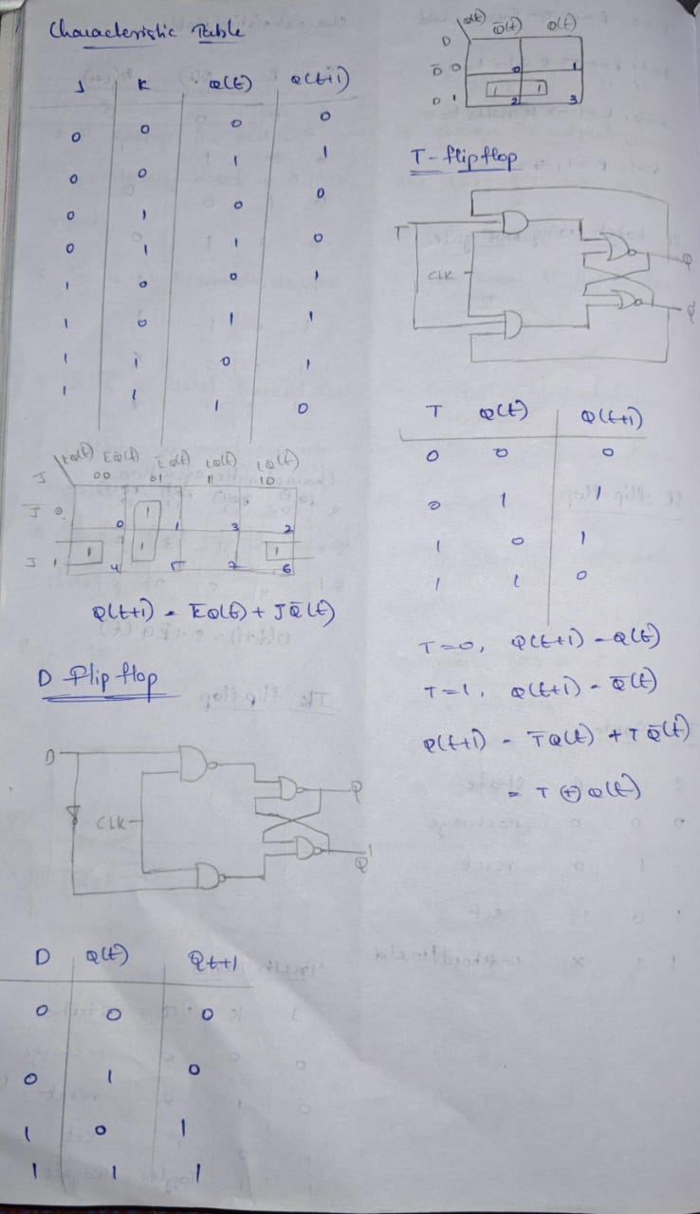  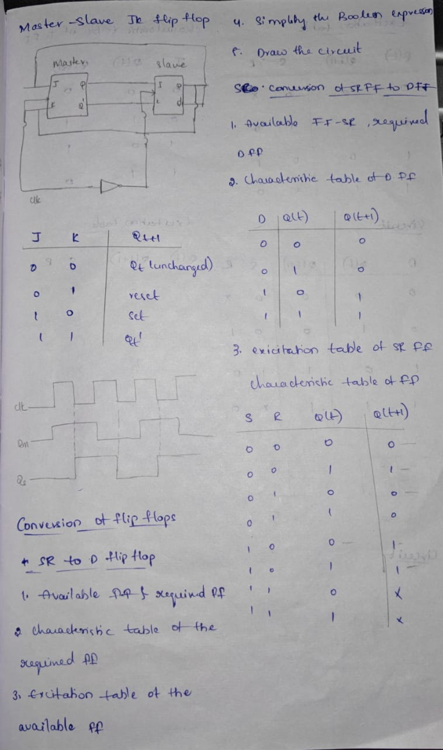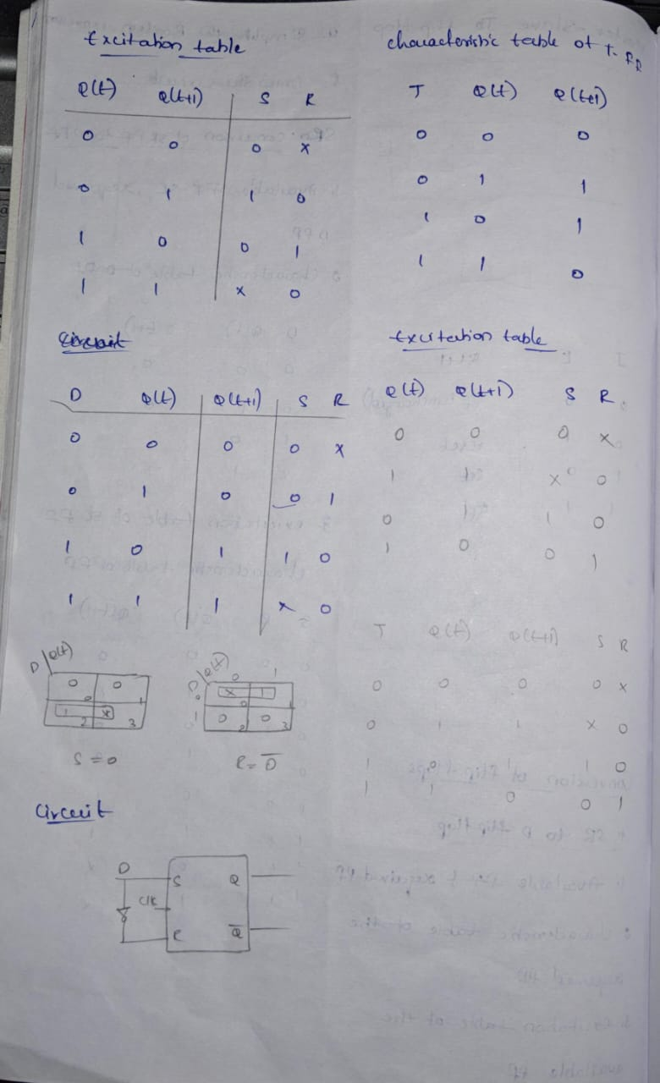
4. Application (Practical Use) | One of the most valuable parts of learning this topic was discovering its applications in real life. Sequential circuits are not just theory; they are used everywhere in technology. Some applications I understood are:  - Computers and Laptops: Flip-flops are used as memory storage elements. Without them, computers cannot store even a single bit of data.  - Digital Watches and Clocks: T flip-flops are used in counters to keep track of seconds, minutes, and hours. Every time the toggle changes, the count increases.  - Calculators: When we press a number or operator, the circuit remembers it until the next operation is performed. This is done using flip-flops and latches.  - Traffic Light Controllers: Sequential circuits are used to control the timing and sequence of red, yellow, and green lights.  - Communication Systems: Flip-flops help in storing and transferring data signals without loss.  - Registers and Counters: D flip-flops are used in shift registers, which move data from one place to another inside a processor.  - Microprocessors and Microcontrollers: The heart of every digital device depends on sequential circuits for memory and timing.  These applications showed me that even though a flip-flop is a very small part of a circuit, without it, big machines like computers and communication systems cannot function. This motivated me to learn more seriously because I realized I was studying the building blocks of modern technology.
Conclusion | In conclusion, learning about sequential circuits, latches, and flip-flops was a valuable experience for me. At first, I faced difficulties because the topic seemed too technical and involved a lot of new concepts. But with continuous practice, I understood how these circuits work and how they are applied in real-world systems. This topic helped me to improve my logical and analytical thinking because I had to carefully follow the steps of how input, output, and clock signals interact. It also made me appreciate how small circuits can control big systems like computers and traffic lights. Most importantly, I learned that memory and timing are the backbone of digital electronics, and sequential circuits make this possible. The journey from confusion to clarity made me more confident in my ability to learn advanced electronics in the future. This topic motivated me to stay patient, practice regularly, and always try to link theory with practical applications.

